Jenkins pipeline with docker image

1. Creating docker python-image with cloning github repository with calculator-python script in it.

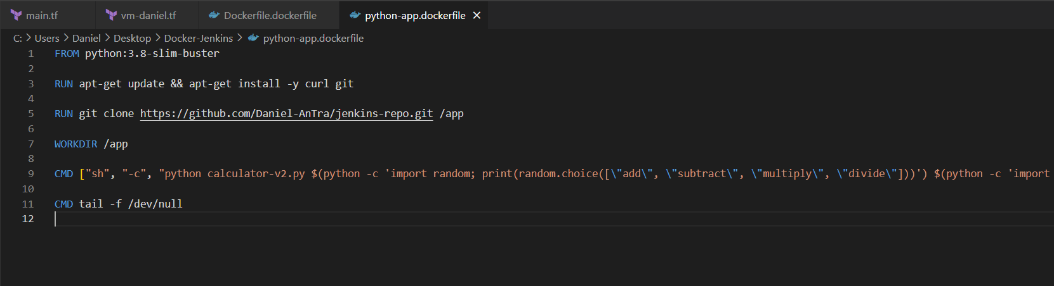

1. Creating docker container from that image with Jenkins pipeline. Executing the calculator-python script from the pipeline.

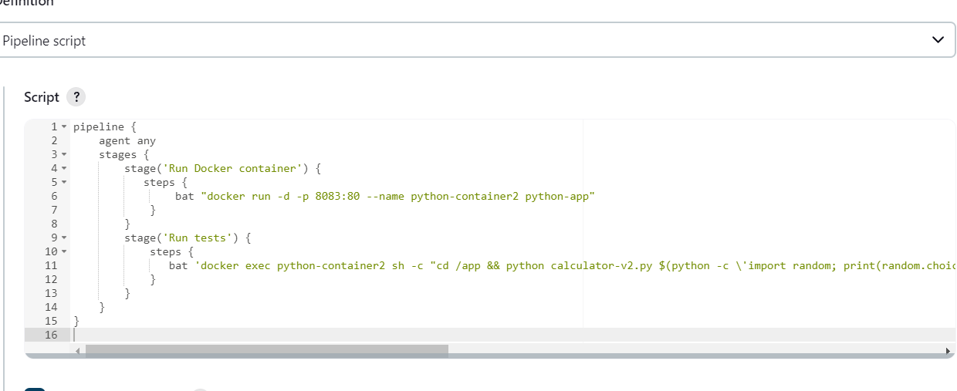

Docker container is created .

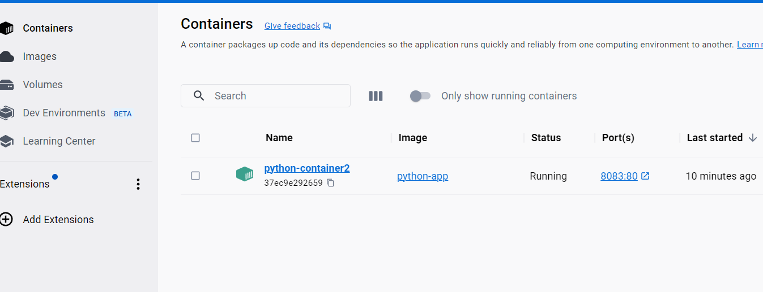

And finally after a loooot of tries and a lot of time (108 builds) I made it work and run the script. (first was giving me error because python is outdatet in Jenkins so that is why I needed to create python docker image in container and after errors with the path , it was a problem finding the file…. So after a lot of tries finally ☺ )  


